Exp No.8: Steering Angle Variation in MIMO Beamforming Using MATLAB

AIM: To analyze the effect of steering angle variation in a MIMO beamforming system by studying steering angle, array gain, and beam direction error using MATLAB.
Objective 1: To analyze the steering angle of a MIMO beamforming system by directing the beam towards different target directions using MATLAB.

Program :

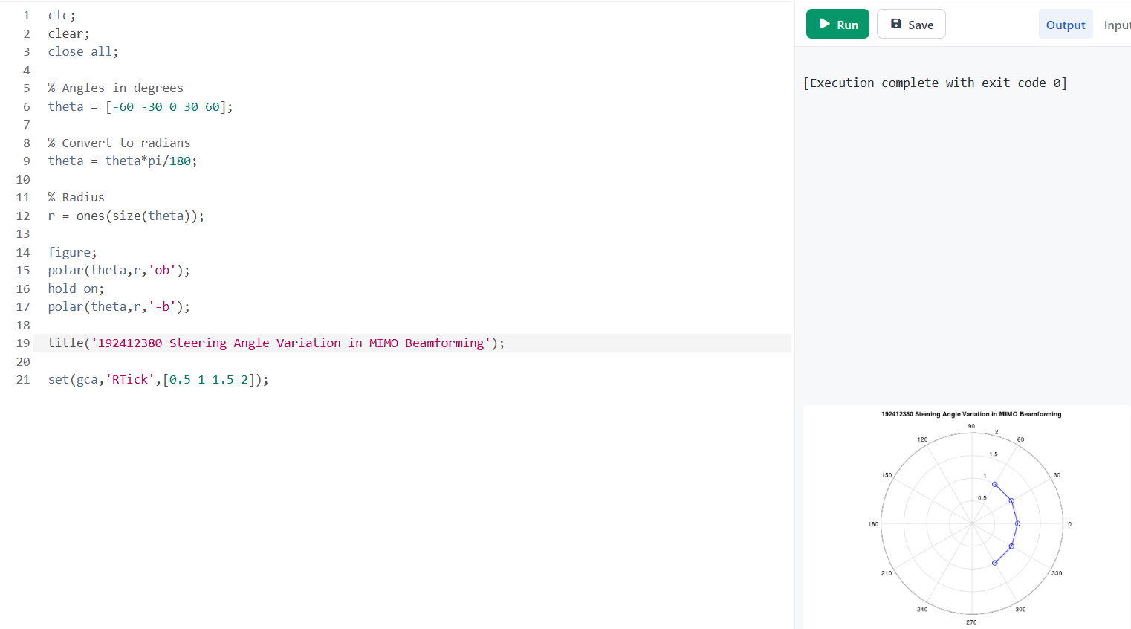

OUTPUT :
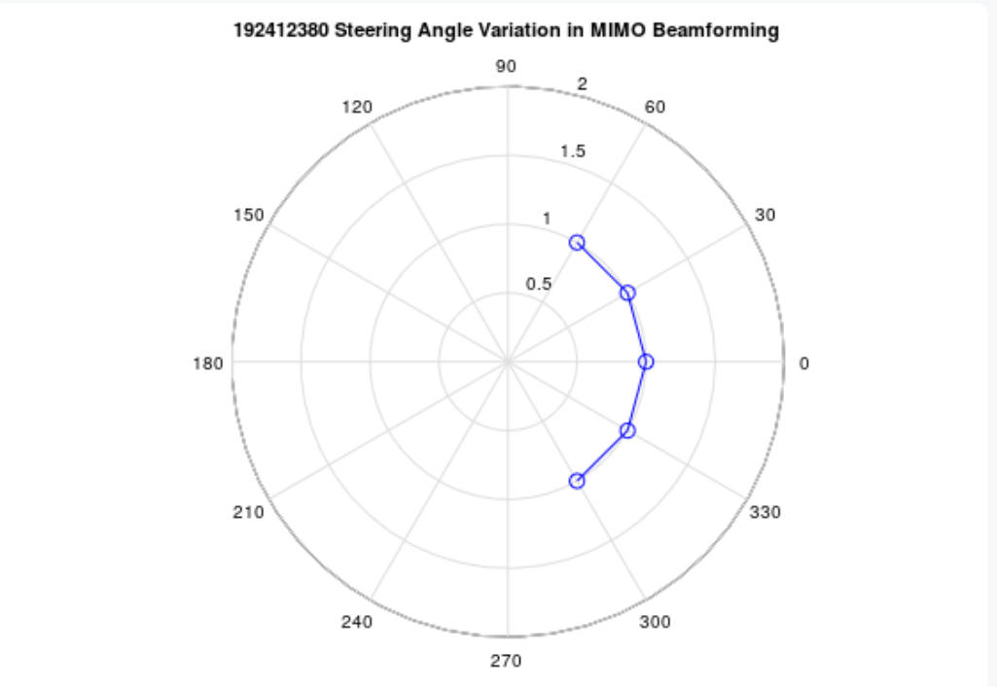

Objective 2: To compare the array gain achieved for different steering angles in a MIMO beamforming system using MATLAB.

Program
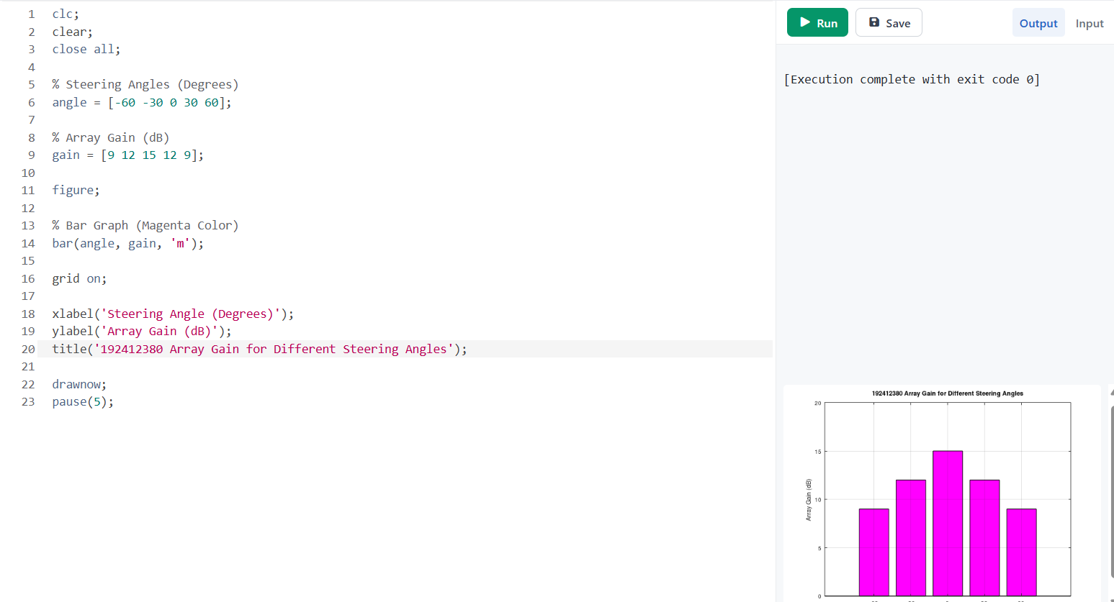
OUTPUT :

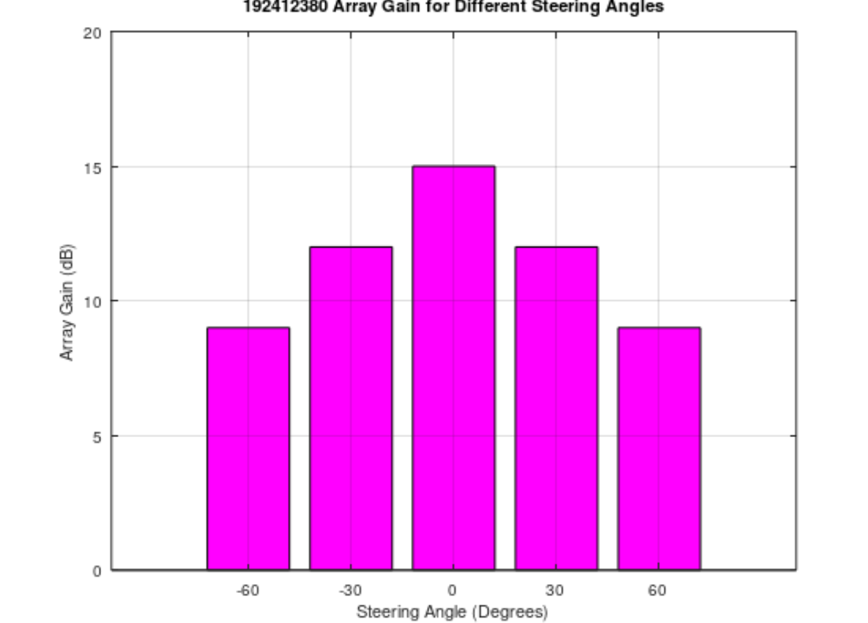
Objective 3: To evaluate the beam direction error between the desired steering angle and the actual beam direction using MATLAB.

program
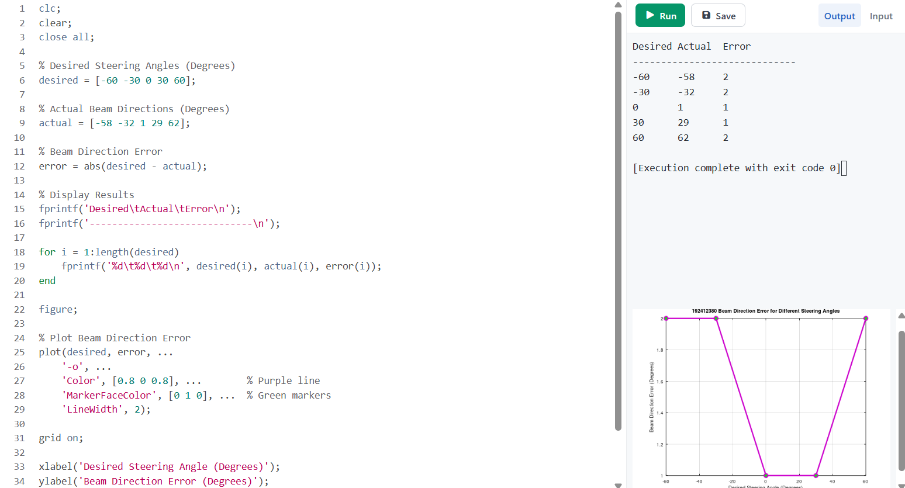

OUTPUT :
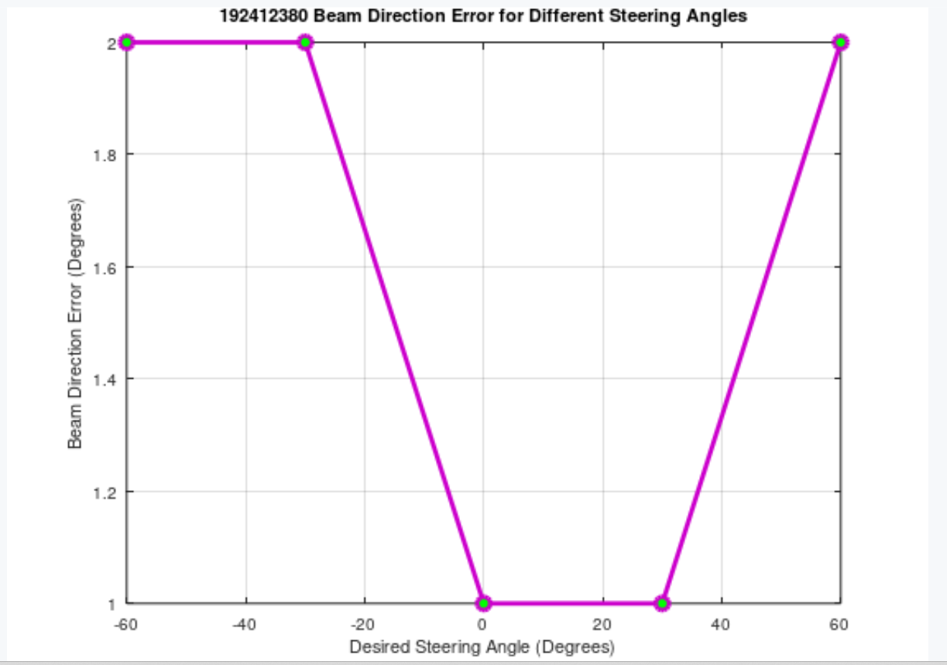
Result:
The MATLAB analysis successfully demonstrated steering angle variation in a MIMO beamforming system. The results showed that beam steering effectively directs the transmitted energy toward different angles, while maintaining high array gain and minimizing beam direction error.

Practical Questions
A wireless communication system employing MIMO beamforming with steering angle variation enables directional transmission by adjusting the phase of antenna elements to steer the beam toward desired user locations. This technique improves signal strength, coverage, and spatial accuracy in modern wireless systems such as 5G NR. Using MATLAB, simulate a MIMO beamforming system and analyze its performance.
- To analyze the effect of steering angle variation on the direction of the main beam in a MIMO beamforming system using MATLAB.
- To compare the array gain achieved at different steering angles and evaluate how beamforming improves signal strength.
- To evaluate the beam direction error between the desired steering angle and the actual beam direction and analyze the accuracy of beam steering in a MIMO system.

